Research Article
Taxonomic Evaluation of Medicinally Important Plant Families Based on Petal Epidermal Micromorphology and Cluster Analysis
Marrium Khan ¹, Humira Ashraf ² and Madiha Rashid ^{2,}*
¹New World International School, Al Khobar, Saudi Arabia. Email:marriamfahad22@gmail.com
²Department of Botany, Division of Science and Technology, University of Education, Lahore,
Pakistan. Email: humairaashraf130@gmail.com; botanistpk@yahoo.

Corresponding Email: botanistpk@yahoo.
Abstract
To identify the micro morphological differences and taxonomic position of plant species, this study was conducted to assess the petal epidermal anatomy of 27 species of ten different families. The light microscopy was employed to observe epidermal cell shape, trichomes, silica bodies, cell size and stomata on both adaxial and abaxial surfaces of the petal. The result showed that trichomes were present only in Cucurbita pepo, while the remaining species had a single layered epidermis without stomata or silica bodies. The considerable variation in epidermal cell shapes, including irregular, hexagonal, pentagonal, and polygonal, was noticed in different plant species. These findings revealed that petal epidermal characteristics of plant species can be utilized as reliable diagnostic tools to assess the interspecific and intra family relationships. Further molecular and phylogenetic analyses should be incorporated along with micro morphological data for refine species identification and investigate evolutionary relationships.
Keywords: Epidermis anatomy; Microscopy; Petal anatomy; Stomata; Trichome;
Received: date:----------------- Revised: date:---------------Accepted: date:---------Published: date

Citation: To be added by editorial staff during production.
Copyright: © 2025 by the authors. Submitted for possible open access publication under the terms and conditions of the Creative Commons Attribution (CC BY) license (https://creativecommons.org/licenses/by/4.0/).

Graphical Abstract

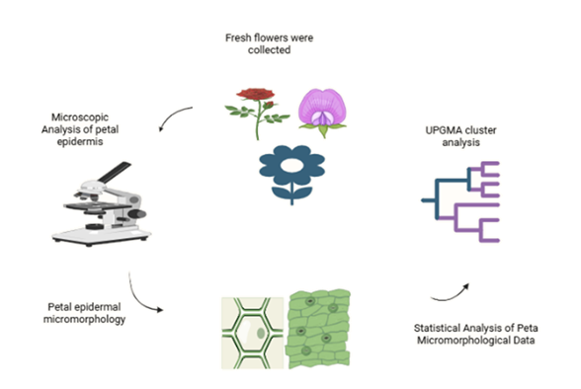

- Introduction
Taxonomy is considered as primer for scientific activities of all plant sciences disciplines. However, most of the taxonomic information of plants accumulated so far is based mainly on morphological markers (Stace, 1980). There are many disciplines associated with taxonomy, which are used by taxonomists as an aid, or to improve the identification, classification and systematic position of plant taxa. Among these disciplines, Anatomy is one of the most significant tools used by modern taxonomist to identify and differentiate closely related taxa (Yousaf et al, 2008). There are number of tree species (Ficus infectoria, Syzigium cumini, Albizzia lebbek) used in the preparation of various compositions of herbal medicines. The sustainable utilization and conservation of plants depend on authentic identification. Most of the taxonomists were agreed on the fact that similarities and dissimilarities of plants can be measure by using morphological markers (Stace, 1980). Morphometry cannot provide solution of complex taxonomic problems. Cercis, an important medicinal species, can easily be distinguished from other genera in Caesalpinioideae by its pseudo papilionaceous flowers, but differences between species of Cercis are minor in terms of both morphological and molecular aspects (Muroi et al., 2012).
Several studies have highlighted the taxonomic significance of petal epidermal traits in various plant taxa. For instance, investigations in the Boraginaceae family demonstrated that the arrangement of epidermal cells can be useful for distinguishing species (Akçin, 2009). In the Apiaceae family, petal epidermal features including cell type, cuticle patterns, and anticlinal wall shapes were found to correlate with phylogenetic groupings, underscoring their value in systematic classification (Kim et al., 2024). Similarly, studies in Bignoniaceae revealed that differences in epidermal cells and trichome types among genera provide insights into evolutionary relationships within the family (Teleb et al., 2024). Stomata and trichomes are considered valuable for species delimitation, as their type, density, and morphology reflect the course of evolutionary relationships (Chitchak et al., 2024; Roudi et al., 2024; Parmar & Zaman, 2022).
Although substantial research has been conducted on plant anatomy, most studies have focused on leaves or individual floral traits. Broad comparative analyses of petal anatomy across multiple families remain limited and largely unexplored. To address gaps in the literature, the present study to examine the petal epidermal micromorphology of 27 species across 10 plant families, using light microscopy combined with hierarchical cluster analysis to identify patterns that may facilitate plant classification. The objective of the study was to examine the of selected plant species.

2. Materials and Methods
The study was conducted to examine the petal epidermal anatomy of 27 plant species from ten different families (Table 1). For petal anatomical studies, fresh petals from living specimens were used. Fresh material of different plant species collected from the different localities of Lahore, Punjab, Pakistan. It including Botanical Garden of Lahore College for women University (31.5447° N, 74.326° E), Bagh-e-Jinnah (31.554° N, 74.331° E), Jilani Park (31.544° N, 74.337° E), and Gulshan-e-Iqbal Park (31.514° N, 74.289° E). Fully expanded flower at least five individuals per species were collected from each species. These flowers immediately transferred to laboratory for petal anatomical analysis.
2.1: Isolation of petal epidermis
For isolation of petal abaxial and adaxial epidermis, petals were soaked for 1 day. Time of soaking was varied according to the texture of petals. Epidermal samples were prepared according to the modified method of Cotton (1974) who followed clerk’s (1960) technique. The fresh petals were placed in test tube filled with 88% lactic acid. Lactic acid is used to soften the tissue of petal due to which it’s peeling off is made possible.
2.2: Preparation of Slides
A sharp blade is used for peeling of petal material. The epidermis was cut across the petal and scrapped away together with the mesophyll cells until only the epidermal layer of the petal remained on the tile. To obtain consistent and statistically reliable anatomical data, five petals were examined and 10–15 epidermal cells per petal were observed from plant species. Slides of both abaxial and adaxial sides of petals were prepared and observed under the light microscope (Model: Meiji techno).

Table 1: List of plant species with their family’s name, explored in the study

Family | Plant Species | Family | Plant Species
Apocynaceae | Nerium oleander L. | Fabaceae | Bauhinia variegata L.
Apocynaceae | Plumeria rubra f. acutifolia (Poir.) Woodson | Fabaceae | Butea monosperma (Lam.) Taub.
Apocynaceae | Plumeria obtusa L. | Fabaceae | Cassia fistula L.
Apocynaceae | Plumeria rubra L. | Fabaceae | Erythrina suberosa Roxb.
Asteraceae | Calendula arvensis L. | Fabaceae | Delonix regia (Bojer ex Hook.) Raf.
Asteraceae | Tagetes erecta L. | Magnoliaceae | Magnolia grandiflora L.
Asteraceae | Calendula indica L. | Magnoliaceae | Plumeria grandiflora Aiton
Asteraceae | Helianthus annuus L. | Malvaceae | Hibiscus rosa-sinensis L.
Asteraceae | Zinnia elegans L. | Rosaceae | Rosa beggeriana Schrenk
Cucurbitaceae | Cucurbita pepo L. | Rosaceae | Rosa × grandiflora L.
Euphorbiaceae | Euphorbia splendens Bloxm. | Rosaceae | Rosa indica L.
Euphorbiaceae | Jatropha integerrima Jacq. | Solanaceae | Petunia alba Juss.
 |  | Verbenaceae | Clerodendrum infortunatum L.
 |  |  | Duranta erecta L.

2.3: Photographs of Slides
Microphotographs were taken by using CCD digital camera (model: canon Pc 1200 attached with MD lens MA 151/30/73 opter) fitted on light microscope (model: Meiji techno). Identification of anatomical character was made by using power at high power plan 40×/0.65,∞/0.17,F=200,WD=0.5 and at lower power plan is 10×/0.25,∞/0.17,F=200,WD=7.3. These micrographs were useful for identification and differentiation of epidermal cells on the basis of microscopic features.
2.4: Statistical Analysis
Quantitative anatomical data were subjected to correlation matrix analysis to assess relationships among epidermal characters across species. Cluster analysis was performed to evaluate interspecific similarities based on shared anatomical traits. The Unweighted Pair Group Method with Arithmetic Mean (UPGMA) was employed to group taxa according to overall similarity, as it is widely used in taxonomic and anatomical studies. A dendrogram was constructed to visualize the relationships among the studied species.
- Results
The petiole epidermis of 27 plant species from 10 families was analyzed. Fabaceae and Asteraceae, with five species each, had the greatest representation among all families. Apocynaceae, Cucurbitaceae, Euphorbiaceae, Magnoliaceae, Malvaceae, Rosaceae, Solanaceae, and Verbenaceae each contained one to three species. Four species of Apocynaceae (Nerium oleander L., Plumeria acutifolia Ait., P. obtusa (Linn.), and P. rubra Ait.) have been observed with irregular epidermal cells with long cell lengths ranging from 75.7 µm to 146 µm (Fig 1). Similar irregular to hexagonal cells were observed in Asteraceae species (Calendula arvensis, Calendula indica, Tagetes erecta L., Helianthus annuus L., Zinnia elegans), with long cell lengths ranging from 60.2 µm to 344.7 µm, with Calendula arvensis presenting the longest cells.
The petiole anatomical study revealed that epidermal cells of the family Fabaceae (Bauhinia variegata (Linn.), Butea frondosa, Cassia fistula L., Erythrina suberosa Roxb., Delonix regia) were irregular to pentagonal. Theepidermal cell lengths range from 89.1 µm to 361 µm. The epidermal cells range from Hexagonal to polygonal epidermal cells with lengthy cell lengths up to 352 µm were found in Magnoliaceae and Malvaceae species (Magnolia grandiflora (Linn.) and Hibiscus rosa-sinensis H.).

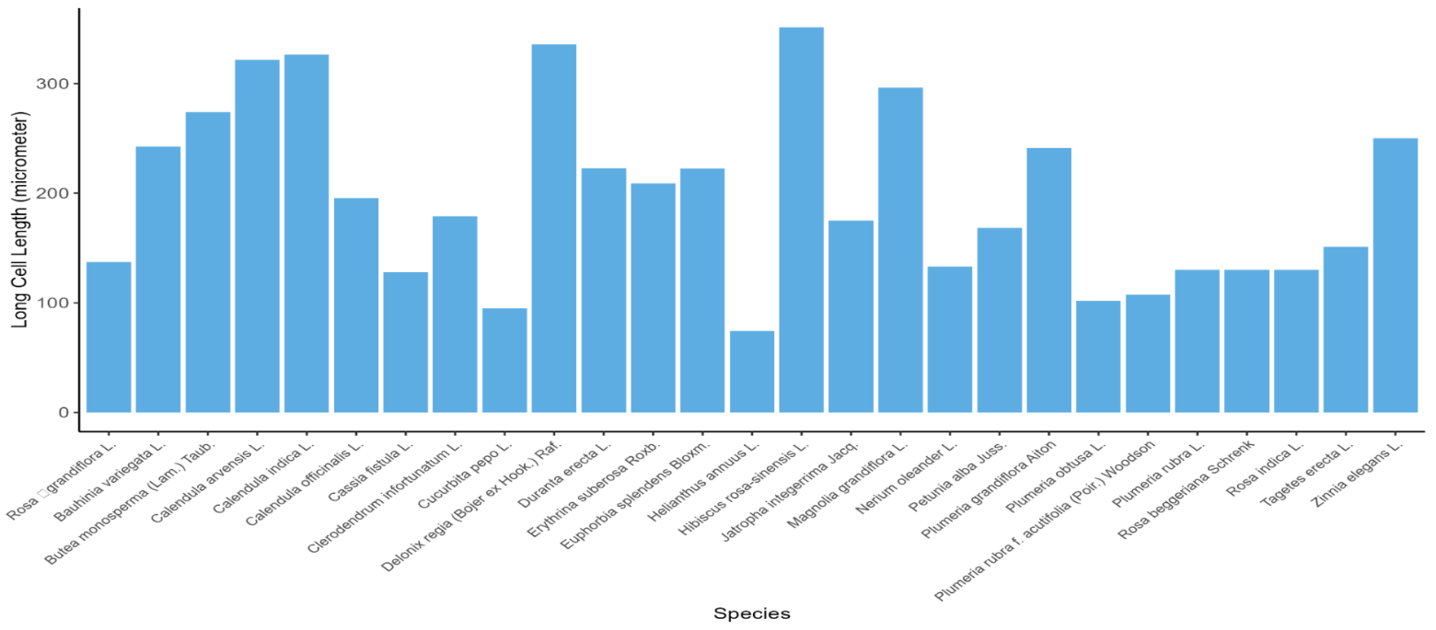
Figure 1. Bar graph illustrating the mean frequency of long epidermal cells in the petals epidermis of species representing different angiosperm families.
In families, Rosaceae, Solanaceae, and Verbenaceae species, varied from 79.2 µm to 228 µm. In the adaxial epidermis of hexagonal cells, the longest cell was observed in all species was 361 µm, indicating a significant variation in epidermal cell size among families. The majority of species lacked trichomes, silica bodies, and stomata in the petiole epidermal surface. The taxonomic diversity and adaptive traits of the examined species can be observed by the variation in epidermal cell size and shape (Fig 2). These findings act as an outline for comparative anatomical research and further investigation of the functional traits of the petiole.

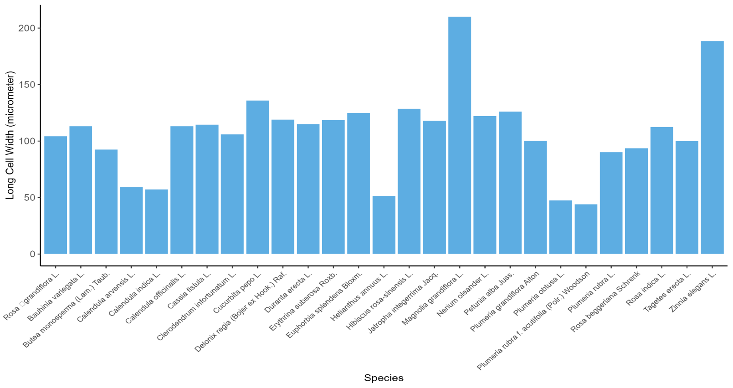
Figure 2. Bar graph illustrating the variation in epidermal cell width among petals of twenty-seven selected angiosperm species.

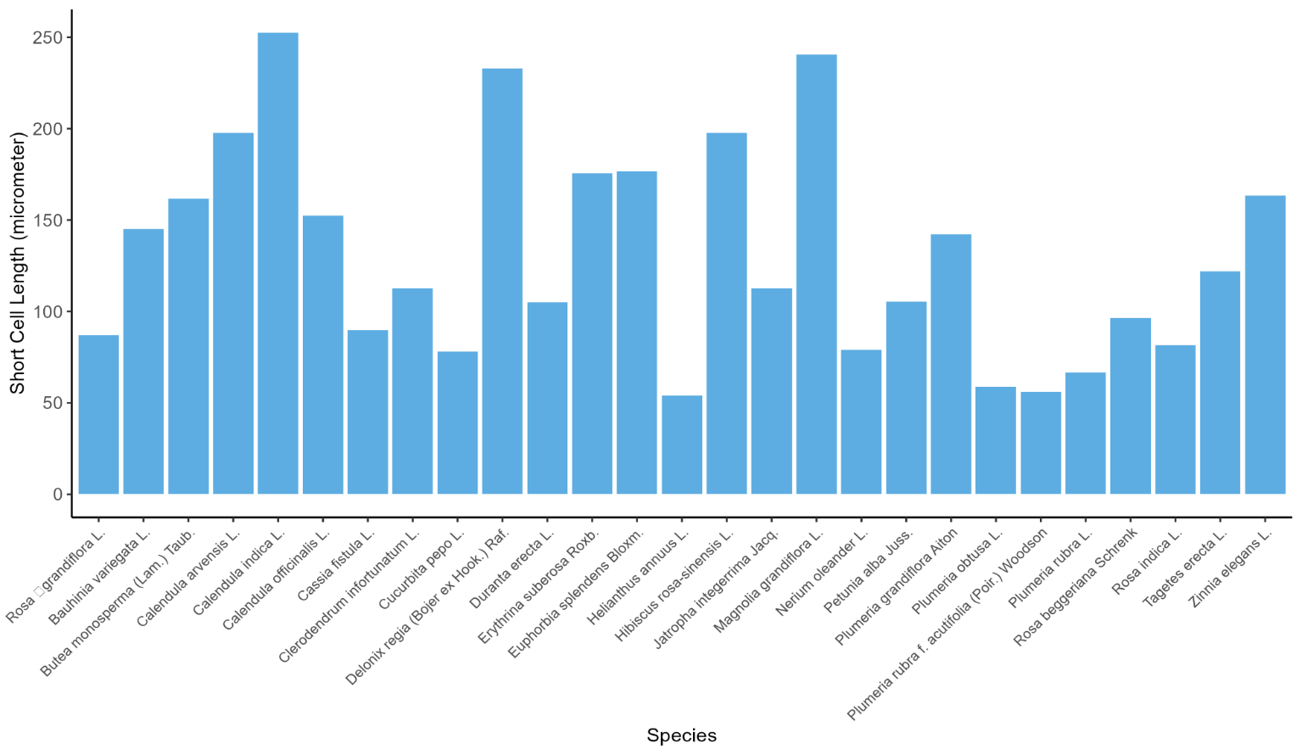
Figure 3. Bar graph illustrating the variation in epidermal short cell length among petals of twenty-seven selected angiosperm species

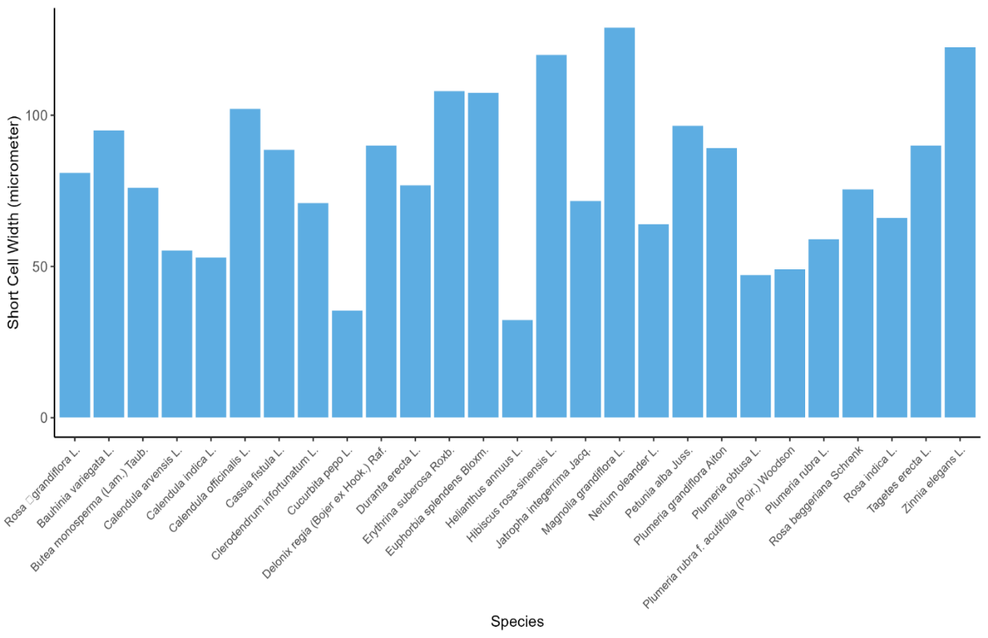
Figure 4. Bar graph illustrating the variation in short epidermal cell width among petals of twenty-seven selected angiosperm species
The petal anatomical study revealed that significant variation in epidermal and supporting structures was present among 26 species (Fig 3). It was observed that stomata were found on the abbatial surface of Euphorbia splendens Bloxm and Calendula indica L. Stomata were present on both the adaxial and abaxial surfaces of Calendula arvensis L. While trichomes were only present in Cucurbita pepo L. None of the species under investigation had silica bodies.
The petal anatomical revealed that epidermal cell shapes vary among Families and species (Fig 4). It was observed that in Apocynaceae, cells were predominantly irregular (except in Plumeria rubra which had pentagonal cells). The irregular cells were observed in Asteraceae, Tagetes, Helianthus, and Zinnia except Calendula species that exhibited hexagonal epidermal cells. Several species of Fabaceae and Cucurbita pepo had irregular epidermal cells. Whereas, Fabaceae family had greater diversity in epidermal cell including irregular, hexagonal, pentagonal, and polygonal forms. Euphorbiaceae, Magnoliaceae, Solanaceae, and Malvaceae families exhibited Surface-specific variation. The Fabaceae species showed considerable variation: Bauhinia variegata and Erythrina suberosa had irregular cells (Fig 7 and Fig 8). Delonix regia exhibited hexagonal cells, while Cassia fistula and Butea monosperma possessed polygonal or pentagonal cells. Within Rosaceae, only Rosa indica had irregular epidermal cells, whereas other species were characterized by hexagonal cells. Species from Malvaceae and Solanaceae generally exhibited irregular epidermal cells. Finally, in Verbenaceae, Clerodendrum infortunatum showed pentagonal cells, while Duranta erecta had irregular cells.
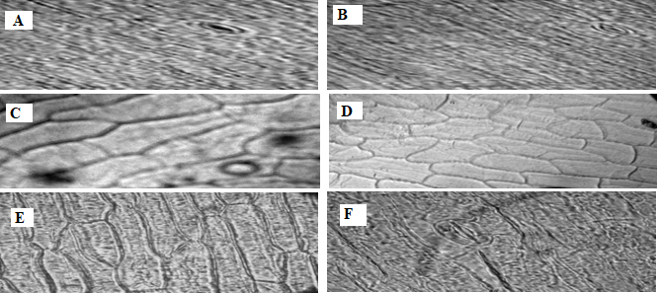 | 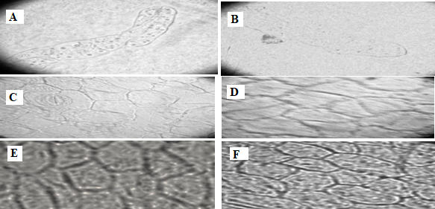
Figure 5: Petal epidermal anatomy of selected species at 40X magnification. A=Calendula arvensis, adaxial, B= Calendula arvensis, abaxial C=Tagetes erecta, adaxial, D= Tagetes erecta, abaxial, E=Calendula indica, adaxial, F=Calendula indica, abaxial. Scale bar = 50 µm. | Figure 6: Petal epidermal anatomy of selected species at 40X magnification. A= Cucurbita pepo, adaxial, B=Cucurbita pepo, abaxial C= Euphorbia splendens, adaxial, D= Euphorbia splendens, abaxial, E=Jatropha integerrima, adaxial, F=Jatropha integerrima, abaxial. Scale bar = 50 µm.

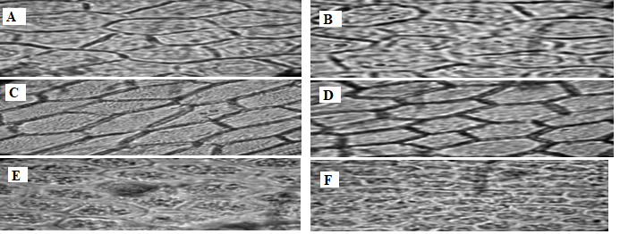 | 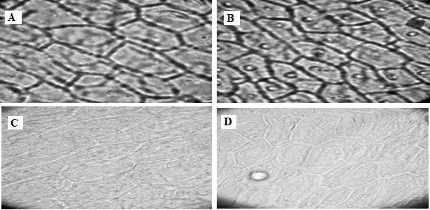
Figure 7: Petal epidermal anatomy of selected species at 40X magnification. A= Bauhinia variegata, adaxial, B= Bauhinia variegata, abaxial, C=Butea frondosa, adaxial, D=Butea frondosa, abaxial, E=Cassia fistula, adaxial F=Cassia fistula, abaxial. Scale bar = 50 µm. | Figure 8: Petal epidermal anatomy of selected species at 40X magnification. A= Erythrina suberosa, adaxial, B= Erythrina suberosa, abaxial, C= Delonix regia, adaxial D=Delonix regia, abaxial. Scale bar = 50 µm.

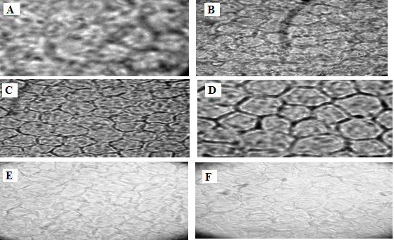 | 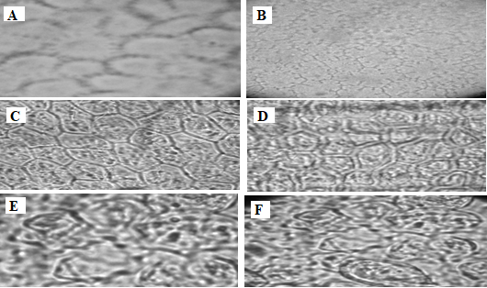
Figure 9: Petal epidermal anatomy of selected species at 40X magnification. A= Rosa beggeriana, adaxial, B= Rosa beggeriana, abaxial, C= Rosa grandiflora, adaxial, D= Rosa grandiflora, abaxial, E= Rosa indica, adaxial, F= Rosa indica, abaxial. Scale bar = 50 µm. | Figure 10: Petal epidermal anatomy of selected species at 40X magnification. A= Petunia alba, adaxial, B= Petunia alba, abaxial, C= Clerodendrum infortunatum, adaxial, D= Clerodendrum infortunatum, abaxial, E= Duranta erecta, adaxial, F= Duranta erecta, abaxial. Scale bar = 50 µm.

The dendrogram was constructed from the petal abaxial and adaxial characters of ten different families. The hierarchical clustering patterns reveal how variation in petiole epidermal traits among 27 species determines their anatomical similarities. Species of the Asteraceae family, Calendula arvensis and Calendula alba, having similar epidermal cell shape, size on their abaxial and adaxial surface of the petal, ( Fig 5)were grouped. Similarly, species of the family Aponaceace, such as Plumeria acutifolia, P. obtusa, and P. rubra, due to their uniform adaxial epidermal structure and identical stomata characters, were clustered in a group. However, species of the cucurbataceae family, Cucurbita pepo, having unique polygonal epidermal cells, form a distinct group. It demonstrated it was different from the rest of the taxa. The border family clusters, i.e. Fabaceae, Rosaceae, Verbenaceae, and Solanaceae, were formed as the dissimilarities increased in epidermal cell structure. The clustering pattern revealed that species were closely related due to their identical epidermal anatomical structure. While distinct taxa were formed due to their distant characters. The results highlight how essential micro morphological characteristics are for understanding variation in structure among angiosperms, evolutionary interpretation, and the identification of species (Fig 11).
Within closely associated taxa, such as Calendula spp. (Asteraceae) and Plumeria spp. (Apocynaceae), the correlational study of petal epidermal features among twenty-seven species exhibited significant similarity, with correlation values often above 0.95, suggesting preserved adaxial and abaxial epidermal features (Table 2 and Table 3). Cucurbita pepo, on the other hand, had low or negative correlations, suggesting distinctive epidermal characteristics that confirmed their separate grouping (Fig 6). These findings confirm the patterns observed in dendrogram investigation and demonstrate that petal epidermal micro-morphological characteristics is an effective tool to identify species and understanding taxonomic relation (Fig 12).

4. Discussion
In taxonomy and plant systematics, macro-morphological characters are considered an important tool to study the relationship among various taxa (Ao et al., 2007). Modern taxonomists use anatomical study for the differentiation of closely related taxa (Bashir et al., 2020). It also assists in the identification of systemic position and classification of taxa (Abeysinghe & Scharaschkin, 2019). The petal anatomical study has a significant role in plant identification and classification (Thacker et al., 2021). The current study was conducted to determine the petal anatomy of twenty-six taxa belonging to ten different families. It helps in the identification of closely related taxa and species.
Present findings revealed that in the Apocynacea family the epidermal cells of mostly plant species were irregular. While the only cells of Plumeria rubra Ait. were pentagonal. Present findings align with the results of Shewale et al. (2022), who reported in Plumeria species epidermal cell were irregular. Aguoru et al. (2015) also investigated the petiole anatomical study of the plumera genus. It was noted that all species had irregular epidermal cells on both their abaxial and adaxial surfaces, except the exception of P. rubra, which had hexagonal and pentagonal cells on abaxial and adaxial surface of leaf epidermal cells. Similarly, the variation that was found in the epidermal cell coincides with the outcomes of Yasmin et al. (2010), who studied the epidermal cells of fifteen Persicaria Mill species and observed differences among them.

Table 2: Co-relation among the species based on petal epidermal anatomical characters at Adaxial Side
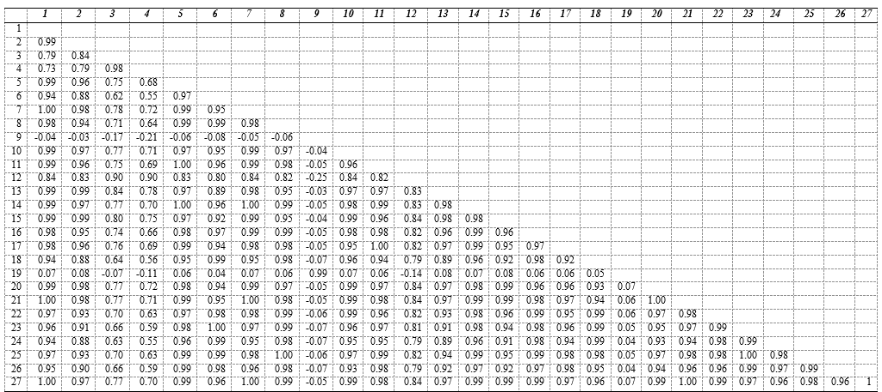
Key

Table 3: Co-relation among the species based on petal epidermal anatomical characters at Abaxial Side
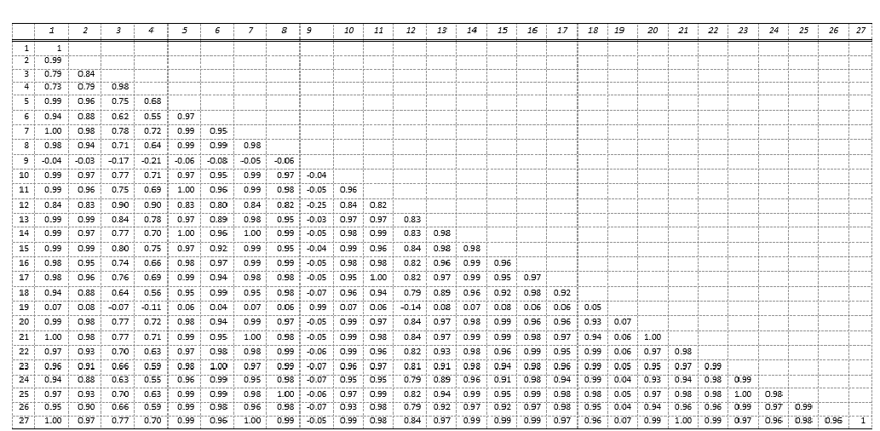

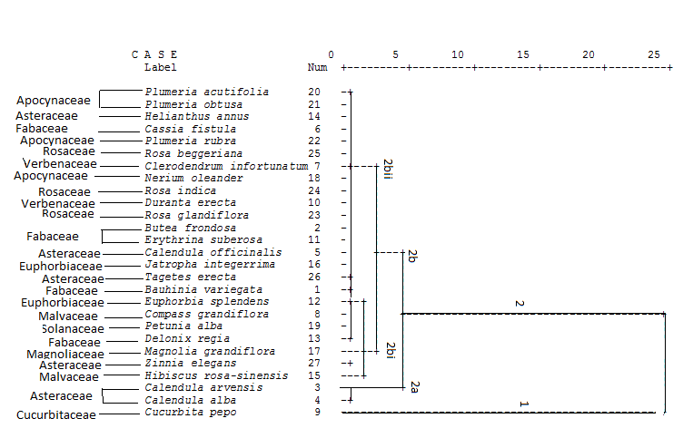 | 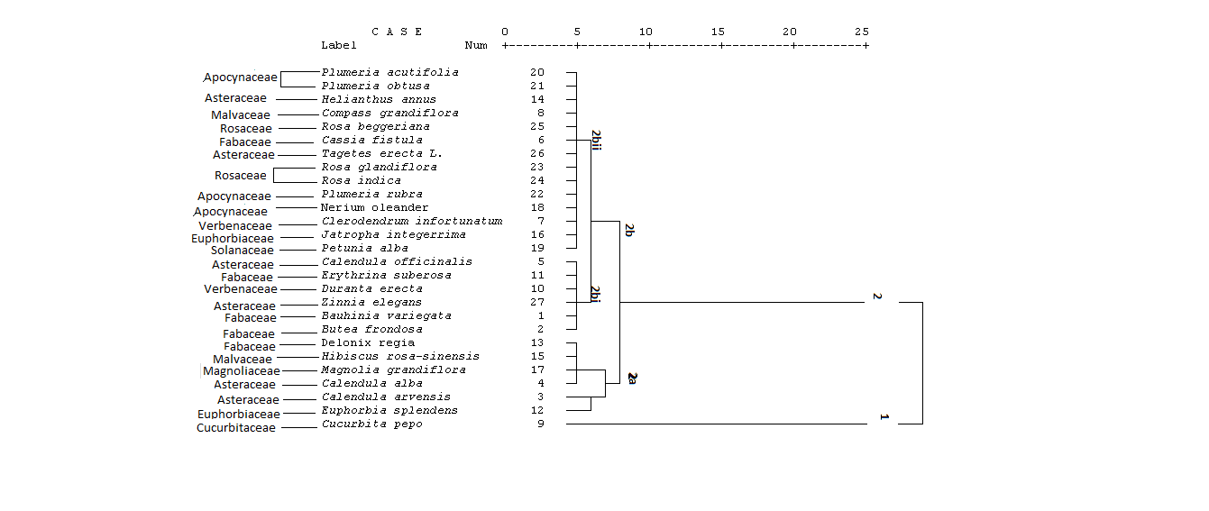
Figure 11: Dendrogram of different species based on Petal epidermal anatomical characters (Abaxial Side) | Figure 12: Dendrogram of different species based on Petal epidermal anatomical characters (Adaxial Side)

Present results showed that in the Family Asteraceae, the epidermal cells of Calendula arvensis and Calendula indica were hexagonal. Current outcomes showed that cells of Helianthus annus L., Zinnia elegans and Tagetes erecta L. were irregular. Stomata, trichomes and silica bodies were absent in both the adaxial and abaxial sides of the petal. Similarly, our results are consistent with the findings of Ismail (2017), who reported that T. erecta has irregular epidermal cells. With only slight variations, our results are mostly in line with earlier research on the petiolar anatomical study of asteraceous plants. The changing climate may be the reason for these variations (Kocsis & Borhidi, 2003). Further, trichomes are known to appear on vegetative parts but are not as common on petals in Asteraceae plants like Helianthus, which is in agreement with current finding of glabrous, astomatous petal surfaces (Aschenbrenner et al., 2013). The lack of trichomes and stomata on petals, for instance, may lower the cost of construction and improve the surface area for pollinator display (Haratym et al., 2019).
Current results revealed that epidermal cells of Cucurbita pepo were irregular. The number of trichomes was 1 per unit area. Our results are also consistent with previous results, which showed that the petal of M. charantia (Coutinho et al., 2009) and L. cylindrica (Vieira et al., 2019) have glandular and tector trichomes. In accordance with Metcalfe and Chalk (1950), both kinds of trichomes were observed in C. anguria and C. dipsaceus. Similarly, according to da Silva et al. (2025) Cucurbitaceae family frequently possesses both glandular and non-glandular trichomes. Present results showed that in Euphorbia splendens, silica bodies and trichomes were absent on both surfaces of the petal. There was one stomata per unit area of the adaxial side of the petal. The cells of the adaxial surface were pentagonal, while the cells of the abaxial surface were polygonal. Our findings revealed that cells of Jatropha integerrima Jacq. were pentagonal. Talebi et al. (2017) found similar variations in abaxial and adaxial cell shapes while analyzing different species of the family Euphorbiaceae. Present results are in line with the study of Bahadur et al. (2022), who studied comprehensive micro morphological patterns observed in Euphorbiaceae. For example, the presence or absence of trichomes and stomata, as well as variations in the shape of epidermal cells, are taxonomically important traits in leaf epidermal studies in Euphorbiaceae. Present results demonstrated that in the family Fabaceae, selected species (Bauhinia variegata, Erythrina suberosa, Butea frondosa, Cassia fistula, and Delonix regia) persistently lacked stomata, trichomes, and silica bodies in their petiole anatomical study. Similar absence of epidermal appendages is considered a persistent, distinctive trait in Fabaceae and has been demonstrated in a recent petiole study (Rajput et al., 2022). The previous research has revealed that the epidermal cell shape is a reliable character for the identification of a species (Filartiga et al., 2022). Present results showed that in Magnolia grandiflora (Linn), the cells of the adaxial surface of the petal were pentagonal, while the cells of the abaxial surface were irregular. In the family Malvaceae, silica bodies, trichomes and stomata were absent in the petals of Compass grandiflora. The cells of the adaxial surface of the petal were polygonal. Present findings revealed that cells of Hibiscus rosa-sinensis H. were irregular. Stomata, trichomes and silica bodies were absent on both sides of the petal.
Similarly, Chachad & Vaidya (2016) found that epidermal cells of Hibisus rosa-sinensis were irregular and had a wavy border. Other studies also revealed that most Malvaceae species have similar features (Al-Saadi et al., 2019; Al-Saadi et al., 2023). In the family Malvaceae, the epidermal cell pattern was observed; variation was found between species, but at the genus level maintains distinctive features (Al-Taie & Al-Saadi, 2024). As a result, the petiole anatomical features, such as cell shape, absence of stomata and trichomes, are reliable taxonomic markers for species identification and comparative study within the family. Present results showed that in the family Rosaceae, the cells of Rosa beggeriana L. and Rose grandiflora L. were hexagonal (Fig 9). However, of epidermal cells of Rosa indica L. were irregular. Our results are consistent with the findings of Song & Hong (2018), who also noted the variation in epidermal cells. All taxa possess varying numbers of epidermal cells: Adenostoma, with diameters ranging from 7.0–20.0 μm; Chamaebatiaria, 11.0–18.0 μm; Lyonothamnus, 8.0–35.0 μm; Sorbaria, 4.0–20.0 μm; and Spiraeanthus, 11.0–16.0 μm. The trichomes were also absent from both surfaces of the petals. Present results revealed that epidermal cells of Petunia alba Juss. were irregular (Fig 10). Current findings showed that cells of Clerodendrum infortunatum (Petal) were pentagonal, while cells of Duranta erecta (Petal) were irregular. Our findings align with the results of Okeke et al. (2015), who observed variation in petiole epidermal cells of different species of the family Verbenaceae. Epidermal cell shape differed among species, varying from irregular to polygonal, hexagonal, and pentagonal. Functionally, the reduction of trichomes and stomata in petioles may indicate that their primary role is transport and mechanical stability instead of gas exchange, and the presence or lack of appendages may also indicate adaptive responses to environmental constraints.
Conclusion
Epidermal micro morphological features are highly beneficial for identifying species and understanding taxonomic relationships, according to an anatomical study of the petal epidermis of twenty-seven species of ten different families. The reliability of these traits in systematic classification was validated by cluster analysis, which showed the species with similar epidermal attributes were typically grouped. While more distinct species, like Cucurbita pepo, exhibited different epidermal characteristics that led to distinct clustering, closely related taxa within groups like Asteraceae and Apocynaceae showed remarkable morphological similarities. All things considered, this study highlights petal epidermal structure as a reliable and instructive strategy that effectively supplements traditional morphology in plant classification. To increase knowledge and improve the taxonomic significance of epidermal features, it is also advised to apply quantitative morphometric indices, compare petal anatomy with leaf and sepal epidermal attributes, and expand the species dataset.
Author Contributions: Conceptualization, MR..; methodology, MK.; software, HA.; validation, MK. and HA.; formal analysis, MK.; investigation, MK.; resources, MR.; data curation, MK.; writing—original draft preparation, MK.; writing—review and editing, MK and MR.; visualization, MR.; supervision, MR.; project administration, MR.. All authors have read and agreed to the published version of the manuscript
Funding: Please add: This research received no external funding
Conflicts of Interest: The authors declare no conflicts of interest
References
Abeysinghe, P. D., & Scharaschkin, T. (2019). Taxonomic value of petiole anatomy in the genus Cinnamomum (Lauraceae) found in Sri Lanka. Ruhuna Journal of Science, 10(1).
Aguoru, C. U., Abah, O. P., & Olasan, J. O. (2015). Systematic Descriptions and Taxonomic studies on Three (3) Species of Plumeria in North Central Nigeria. International Journal of Innovation and Scientific Research, 17(2), 403–411.
Akcin, O. E. (2009). Micromorphological and anatomical studies on petals of 11 Turkish Onosma L.(Boraginaceae) taxa.Bangladesh Journal of Plant Taxonomy, 16(2), 157-164.
Al-Taie, S. S. K., & Al-Saadi, S. A. A. (2024). Comparative study of upper and lower leaf epidermis and trichomes in some species belonging to Malvaceae family. Basrah Journal of Agricultural Sciences, 38(1), 1–15.
Ao, C., Ye, C., & Zhang, H. (2007). A systematic investigation of leaf epidermis in Camellia using light microscopy. Biologia, 62(2), 157-162.
Aschenbrenner, A. K., Horakh, S., & Spring, O. (2013). Linear glandular trichomes of Helianthus (Asteraceae): morphology, localization, metabolite activity and occurrence. AoB Plants, 5, plt028.
Bahadur, S., Ahmad, M., Long, W., Yaseen, M., & Hanif, U. (2022). Leaf Epidermal Traits of Selected Euphorbiaceae and Phyllanthaceae Taxa of Hainan Island and Their Taxonomic Relevance. Diversity 2022, Vol. 14, Page 881, 14(10), 881.
Bashir, K., Sohail, A., Ali, U., Ullah, A., Ul Haq, Z., Gul, B., & Asghar, M. (2020). Foliar micromorphology and its role in identification of the Apocynaceae taxa. Microscopy Research and Technique, 83(7), 755-766.
Chachad, D. P., & Vaidya, M. (2016). Stomatal studies on some selected plants of Malvaceae. World Jouranl of Pharmaceutical Science, 5, 1060-1068.
Chitchak, N., Stewart, A. B., & Traiperm, P. (2024). Intergeneric comparison of staminal trichomes in the tribe Ipomoeeae (Convolvulaceae). Plants, 13(15), 2050.
Clarke, J. (1960). Preparation of leaf epidermis for topographic study. Stain technology, 35(1), 35-39.
Cotton, R. (1974). Cytotaxonomy of the genus Vulpia. The University of Manchester (United Kingdom).
Coutinho, F. D., Catunda Florêncio, J., Reis Aguiar, L., & de Castro Borba, E. (2009). Estudo farmacobotânico das folhas de Momordica charantia L.(CUCURBITACEAE) Pharmacobotanical study of leaves of Momordica charantia L.(CUCURBITACEAE).
da Silva, E. M., Magalhaes, C. D. S., & Randau, K. P. (2025). Comparative Anatomical, Histochemical, and Phytochemical Characterization of Species of the Genus Cucumis L. Microscopy Research and Technique, 88(3), 658-667.
de Andrade Silva, F. K., dos Santos Magalhães, C., Sá, R. D., da Silva, F. C. L., & Randau, K. P. (2020). Anatomical and histochemical study of Sechium edule (Jacq.) Sw. Annals of Biology, 42, 173–181.
Filartiga, A. L., Klimeš, A., Altman, J., Nobis, M. P., Crivellaro, A., Schweingruber, F., & Doležal, J. (2022). Comparative anatomy of leaf petioles in temperate trees and shrubs: the role of plant size, environment and phylogeny. Annals of Botany, 129(5), 567-582.
Haratym, W., Weryszko-Chmielewska, E., & Konarska, A. (2020). Microstructural and histochemical analysis of aboveground organs of Centaurea cyanus used in herbal medicine. Protoplasma, 257(1), 285-298..
Ismail, Z. A. L. (2017). Anatomical study of Tagetes erecta (L.) (Asteraceae). International Journal of Sciences: Basic and Applied Research, 36(3), 2307–4531
Kim, K. H., Oak, M. K., & Song, J. H. (2024). Petal epidermal micromorphology of Korean Peucedanum L. species (Apiaceae) and its systematic significance. Journal of Asia-Pacific Biodiversity, 17(3), 532-540.
Kocsis, M., & Borhidi, A. (2003). Petiole anatomy of some Rubiaceae genera. Acta Botanica Hungarica, 45(3-4), 345-353.
Kshirsagar, A. A. (2012). Anatomical Studies of Leaves in Some Species of Ammannia L.(Lythraceae). Journal of Chemical, Biological and Physical Sciences (JCBPS), 3(1), 228.
Muroi, M., Hayakawa, H., Minamiya, Y., Ito, K., Arakawa, R., & Fukuda, T. (2012). Comparative morphology and anatomy of floral symmetry in legumes (Fabaceae). Journal of Plant Studies, 1(2).
Okeke, C. U., Iroka, C. F., Izundu, A. I., Okereke, N. C., Onwuasoeze, C. I., & Nyananyo, B. L. (2015). Comparative systematic leaf and petiole anatomical studies of the genus Stachytarpheta found in Awka Nigeria. ~ 82 ~ Journal of Medicinal Plants Studies, 3(4), 82–84.
Parmar, G., & Zaman, W. (2022). Trichomes’ micromorphology and their evolution in selected species of Causonis (Vitaceae). Horticulturae, 8(10), 877.
Payne WW (1978) A glossary of plant hair terminology. Brittonia 30(2):239–255.
Rajput, K. S., Dayatar, S. R., Lekhak, M. M., & Gondaliya, A. D. (2022). Petiole anatomy of some species of Bauhinia L. sensu lato (Leguminosae Juss.) occurring in India. Nordic Journal of Botany, 2022(2), e03303.
Roudi, E., Khodayari, H., Mozaffarian, V., & Zarre, S. (2020). Trichome micromorphology and its significance in the systematics of Convolvulus L.(Convolvulaceae).Turkish Journal of Botany, 44(2), 178-191.
Sheteolu, A. O., & Ayodele, A. E. (1997). Epidermal morphology of the genus Dialium (Fabaceae: Caesalpinoideae). Feddes Repertorium, 108(3‐4), 151-158.
Shewale, S., Undale, V., Shelar, M., Pimple, B., Kuchekar, M., Bhalchim, V., & Warude, B. (2022). Morphological and anatomical characterization of Plumeria obtusa L.: An Ayurvedic medicinal plant. Annals of Phytomedicine, 11(2), 787-793.
Song, J. H., & Hong, S. P. (2018). Comparative petiole anatomy of the tribe Sorbarieae (Rosaceae) provide new taxonomically informative characters. Nordic Journal of Botany, 36(5), njb-01702.
Talebi, S. M., Noori, M., & Naniz, H. A. (2017). A study of epidermal leaf anatomy of 18 Euphorbia taxa from Kerman Province, Iran. Biologija, 63(2), 126–133.
Teleb, S. S., Hussein, H. A., Shaheen, R., & El-Demerdash, M. M. (2024). Petal epidermal micromorphology and its taxonomic significance in some species of Bignoniaceae from Egypt. Bulletin of the Iraq Natural History Museum (P-ISSN: 1017-8678, E-ISSN: 2311-9799), 18(2), 297-313.
Thacker, K. D., Gavade, S. K., Lekhak, M. M., Gondaliya, A. D., & Rajput, K. S. (2021). Comparison of petiole anatomy in Flemingia and its potential for delimitation of species. Flora, 278, 151790.
Theobald, W., & Krahulik, J. R: Rollins 1979. Trichome description classification. Anatomy of the Dicotyledons (Metcalfe, C & L. Chalk eds.), 40-53.
Vieira, L. E. B., Damasceno Sá, R., & Randau, K. P. (2019). Anatomical and Histochemical Characterization of Leaves of Luffa cylindrica (L.) M. Roem. Pharmacognosy Journal, 11(3), 511–514.
Yasmin, G., Ajab Khan, M., Shaheen, N., & Qasim Hayat, M. (2010). Taxonomic significance of leaf epidermal anatomy of selected Persicaria Mill. species of family Polygonaceae from Pakistan. African Journal of Biotechnology, 9(25), 3759–3768.
Yousaf, Z., Shinwari, Z. K., Asghar, R., & Parveen, A. (2008). Leaf epidermal anatomy of selected Allium species, family Alliaceae from Pakistan. Pakistan Journal of Botany, 40(1), 77.
Zou, P., Liao, J., & Zhang, D. (2008). Leaf epidermal micromorphology of Cercis ( Fabaceae: Caesalpinioideae). Botanical Journal of the Linnean Society, 158(3), 539–547.

